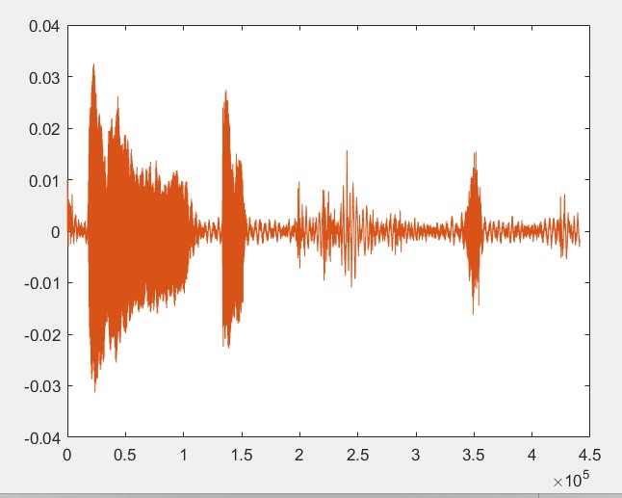1

Pere Garcés, David Petitbó i Victor Navarro

- **INTRODUCTION**

The main objective of this lab session is to simulate and characterize several acoustic effects using MATLAB and some basic tools of digital signal processing. More concretely, the objective is to simulate the acoustic reverberation (i.e., the echoes) in a room.

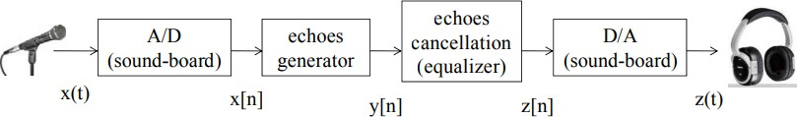

“Figure 1”

* A/D (Analogical to Digital): digitalization of the analogical signal.
* Echoes generator: simulate the effect of the acoustic reverberation in a room.
* Echoes cancellation: remove the echoes from the “dirty signal”.
* D/A (Digital to Analogical): produce the analogical signal from an input digital signal.

The parts of echo generation and echoes cancellation will be divided into: simple echo (just one echo) and multiple echoes (more than one echo).

To finish, the idea is to play the voice signal after it has been processed by all the programmed systems.

# - PROCEDURE FOR PAPER SUBMISSION

## Analogical to digital

In this first section, our function must convert a signal from analogical to digital, this signal will be created by us using our microphone.

To do this, we built two different functions, one that will record our voice and another one that will translate and play the voice.

“Figure 2” This figure represents the signal that we generated.

## Simple Echo

In this section, we needed to create a function that will create echoes

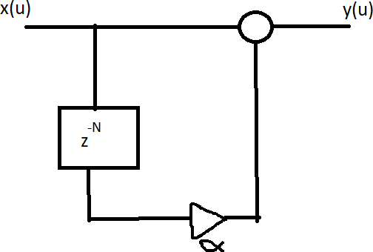

“Figure 3” This figure shows the programming diagram for the system.

This simple function will be used to create a simple echo, where x(n) is our voice, α is the amplitude and N is the delay that we will insert.

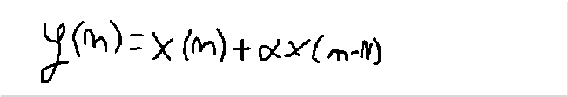

ul ati on of Ac ou sti c Ec ho es

1

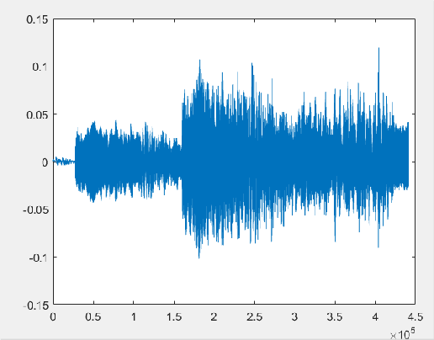

“Figure 4” This figure shows the signal, with the echo, generated by the function.

## Multiple Echoes

In this section, we wanted to generate more echoes.

This simple equation allowed us to do it, where x(n) is our voice, α is the amplitude of echoes and N is the delay.

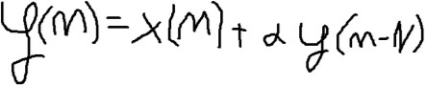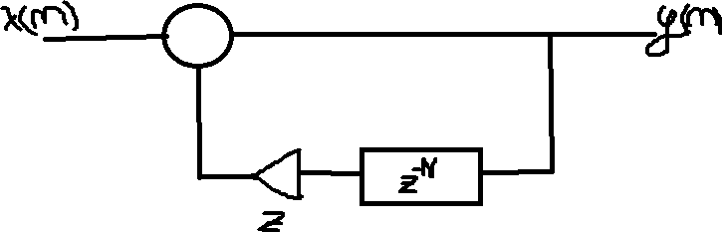

“Figure 5” This figure shows us the programming diagram for the system.

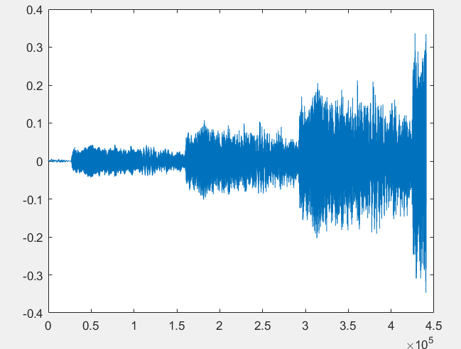

“Figure 6” This figure shows the new signal with multiple echoes.

## Simple Echo Equalizer

In this section, we need to create a function that allows us to remove all the echo generated before (**Simple Echo**).

This equation will remove all the simple echo, where y(n) is our voice signal, α is the amplitude of echo, and N is the delay implemented.

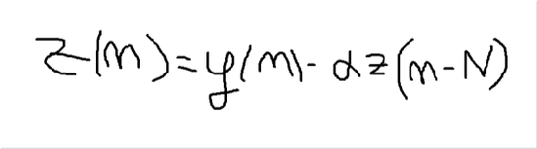

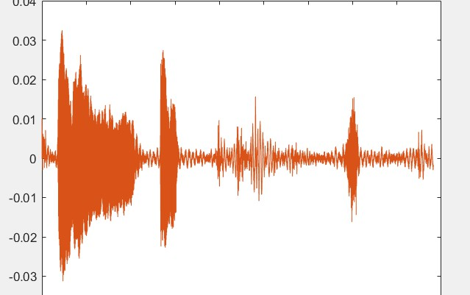

“Figure 7” This figure shows us the signal without the simple echo, so it’s exactly the same as Figure 2.

## Multiple Echoes Equalizer

In this last section, we needed to create a function that removed all the echoes generated in section **Multiple Echoes.**

This equation will remove all of them, where y(n) is our voice, α is the amplitude and N is the delay.

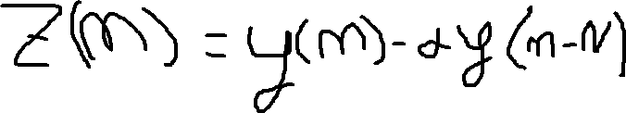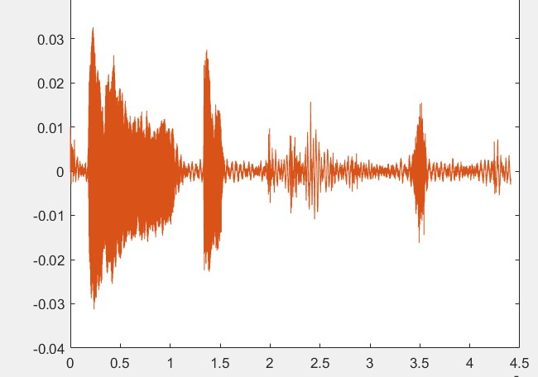

“Figure 8” This figure shows us the signal without all the echoes created before, so it’s exactly the same as Figure 2.

# - COMMON MISTAKES

Some of the mistakes that we had were during the creation of the different functions, as we were creating new voices and not using the ones made before.

Also we could have created better noises with using different word so it will be easier to differentiate between the original and the echo.

- **UNITS**

We used these units in order to make the variables:

* t in seconds
* fs in Hz
* N (delay) in seconds

# CONCLUSION

To conclude, we want to say that in this first practice, we’ve learned how to generate voices and represent them using the Matlab tool. Also, it was important to know how to create echoes and remove them after.

We think that practicing with this type of tools is important in order to do the learning by doing about this subject.

# REFERENCES

1: Video explicatiu Pràctica 1 https://drive.google.com/file/d/1HNU1EM- UKwhV4DQgnsdZWzyr_FZp3fWn/view

2: Introduction to Matlab https://atenea.upc.edu/pluginfile.php/3123187/mod_re source/content/3/Background_Study_Introduction_to_ MATLAB.pdf